**Lyallpur Khalsa College Technical Campus, Jalandhar**





# **A**

**Project Report**

**On**

“**MULTIFACTOR DETECTION SYSTEM**”

[face,eyes,fullbody,smile]

**For The Course**

ARTIFICIAL INTELLIGENCE

**SUBMITTED TO:-** **SUBMITTED BY:-**

ANMOL CHOUDHARY Satyam Kumar Singh

(IBM) Vishal Gupta

Amandeep

**CONTENTS**

| **SR.NO.** | **TABLE OF CONTENTS** | **PAGE NO.** |
| --- | --- | --- |
| 01. | Introduction |  |
| 02. | Software Requirements &  Specifications Document |  |
| 03. | Planning of work |  |
| 04. | System Design |  |
| 05. | Coding |  |
| 06. | Implementation & Testing |  |
| 07. | Snapshots |  |
| 08. | Bibliography |  |

* **INTRODUCTION**

The main objective of the project “MULTIFACTOR DETECTION SYSTEM” is to recognise the face, eyes, body & smile from the webcam and also by showing pictures to the webcam.

* Everyday actions are increasingly being handled electronically instead of pencil & paper or face to face.
* This growth in electronic transactions results in great demand for fast and accurate user identification and authentication.
* Access codes for building, banks accounts & computer systems often use PINs for identification and security. The above mentioned means (keys, badges, passwords, PIN codes) are prone to being lost or forgotten, while fingerprints and retina scans suffer from low user acceptance.
* we need to investigate popular methods of authentication that find mass appeal. This brings us to identification and authentication using FULL BODY RECOGNITION SYSTEM.
* In today’s networked world, the need to maintain the security of information or physical property is becoming both increasingly important increasingly difficult.
* Face recognition is one of the few biometric methods that possess the merits of both high Accuracy.
* Complex and largely Software based technique
* **SOFTWARE & HARDWARE REQUIREMENTS**

This project in python requires you to have basic knowledge of python programming and computer vision library (open CV)

* **Python:-** Python is an interpreted, object-oriented, high-level programming language with dynamic semantics.
* **Open CV**: - It is an open source computer vision and machine learning software library. OpenCV was built to provide a common infrastructure for computer vision applications and to accelerate the use of machine perception in the commercial products.
* **4GB RAM(Minimum)**
* **80GB HDD/SSD (256GB)**
* **OpenCV version 4.1.x** (4.1.0 or 4.1.1 will both work just fine).
* **Python version 3.6** (any Python version 3.x will be fine).
* **Anaconda Python 3** for installing Python and the required modules.
* You can use any **OS—macOS**, **Windows, and Linux-based OS**—with this book.
* **WORK & PLANNING**

Today, along with drones, AI and IoT, facial recognition technology is also defining our millennium. Facial recognition is a biometric technology used for authentication and examination of individuals by correlating the facial features from an image with the stored facial database. Face Recognition is one of the most popular applications of image analysis software and no more considered as a subject of science fiction. Earlier, this technology was only used for security and surveillance purposes, but it has safely transitioned to the real world in recent times. Today, companies are pitching facial recognition software as the future of everything from retail to policing.

So, our group decided that we should have to work on this technology because this technology helps the world in many fields like:

* Access control
* Airport security
* Financial services
* Law enforcement
* Driver’s license & dashboard
* **SYSTEM DESIGN**

**ER MODEL:-**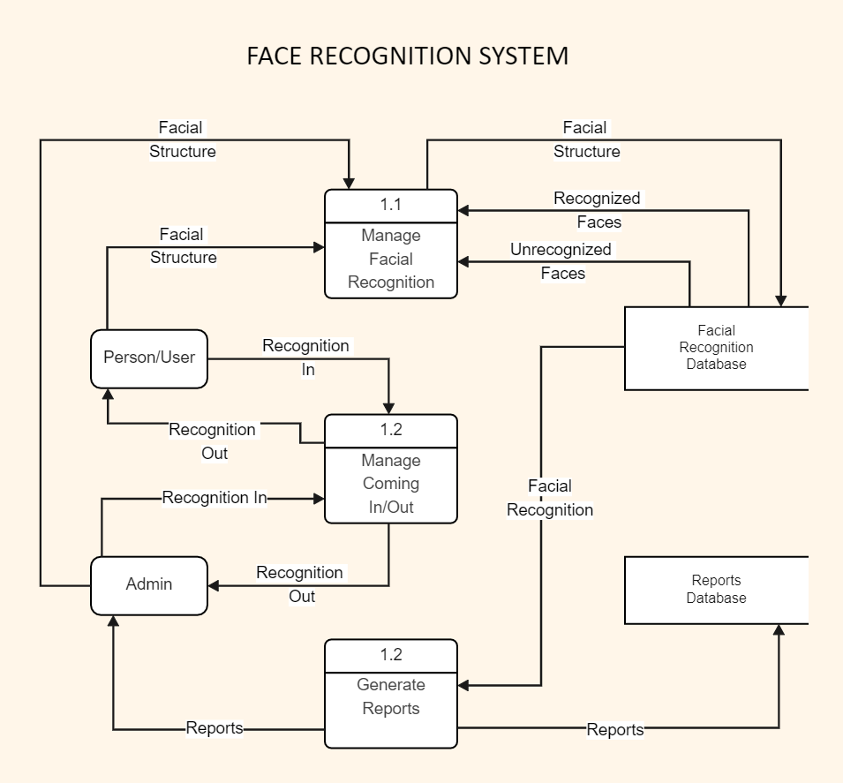

**FLOW CHART:-**

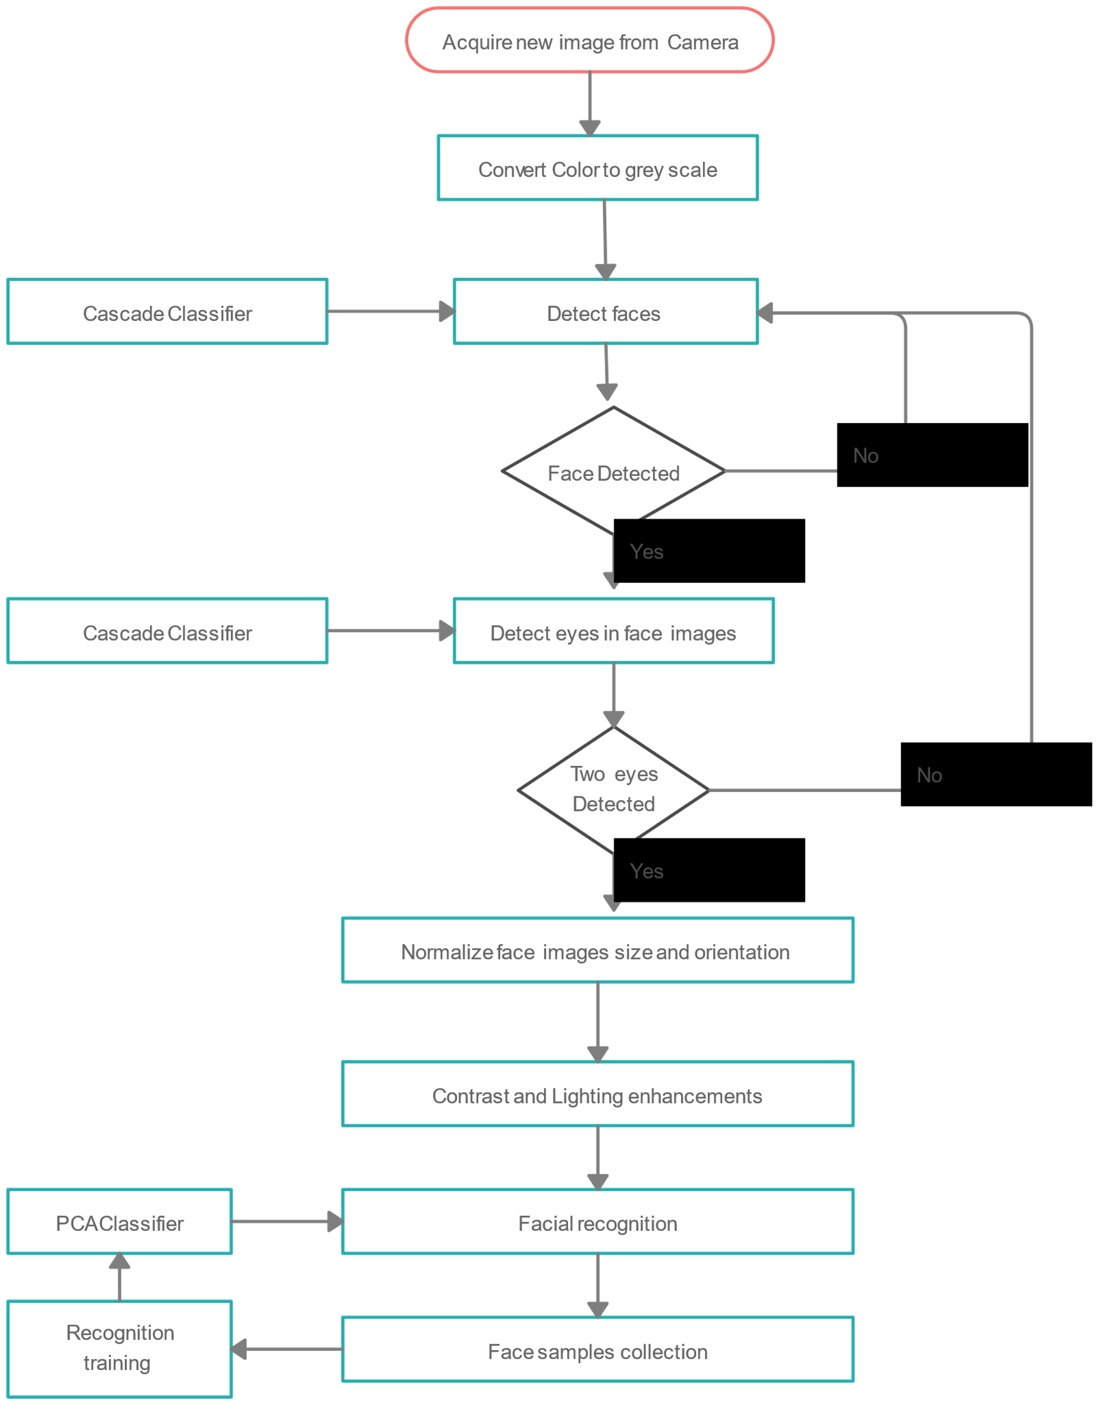

* CODING

**SOURCE CODE:-**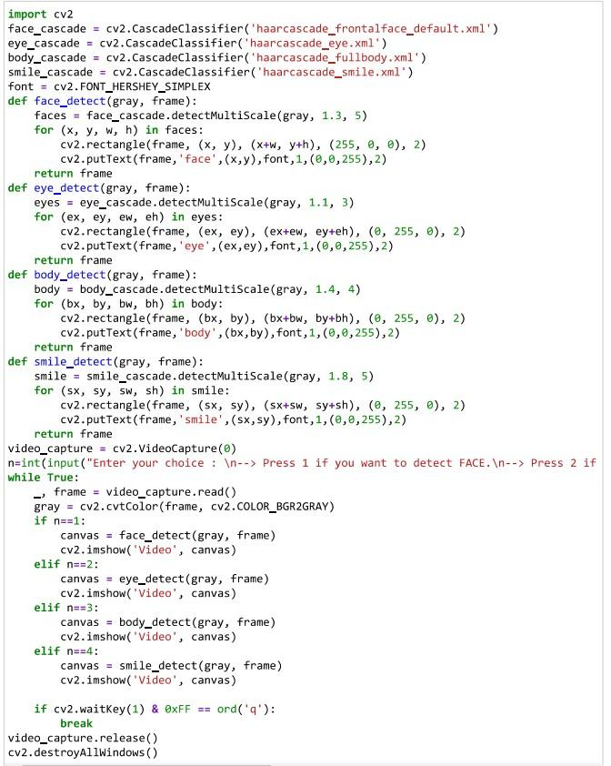

* **IMPLEMENTATION & TESTING**

This is the user defined project. In this project output will be predicted on the basis of user input.

* **Following are steps to implement and testing the model:**
* Step first is to run the code from the respective IDE (control + enter in case of Jupiter notebook) and after that when the program runs successfully then, following instructions are shown on the user screen.
* The instructions are:

Enter your choice:

Press 1: if you want to detect the FACE.

Press 2: if you want to detect the EYES.

Press 3: if you want to detect the FULL BODY.

Press 4: if you want to detect the SMILE.

* Then after when the user give their choice to the system. At that time system open the webcam and recognize the respective BODY PART that user give as input to the system and give the respective output to the user.
* When the user press 1 than the system only recognize the FACE of the user by neglecting the other body parts of the user.
* When the user press 2 than the system only recognize the EYES of the user by neglecting the other body parts of the user.
* When the user press 3 than the system only recognize the FULL BODY of the user by neglecting the other body parts of the user.
* When the user press 4 than the system only recognize the of the SMILE of the user by neglecting the other Body parts of the user.
* SNAPSHOTS

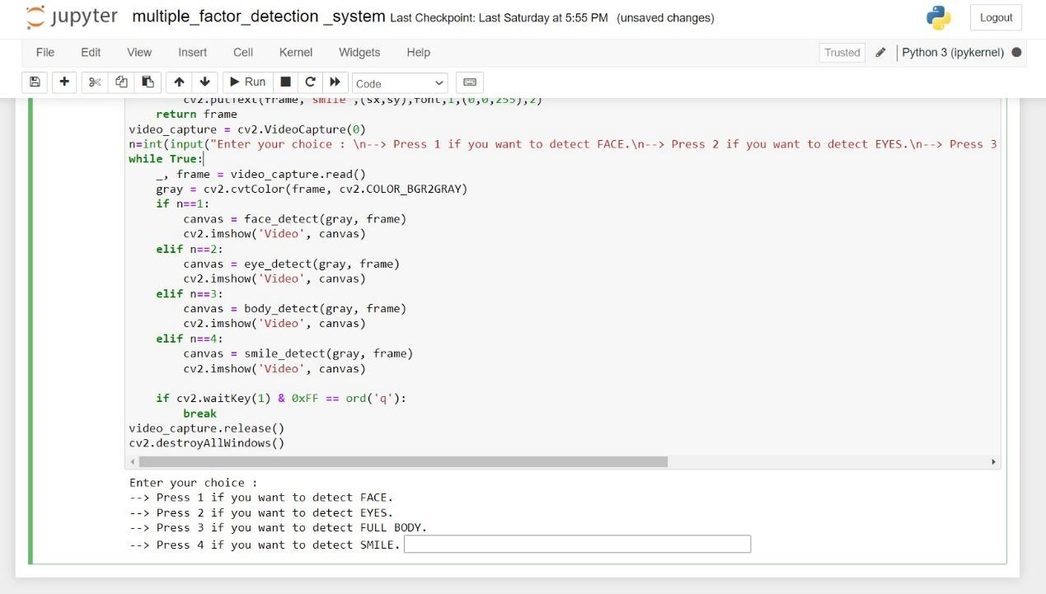

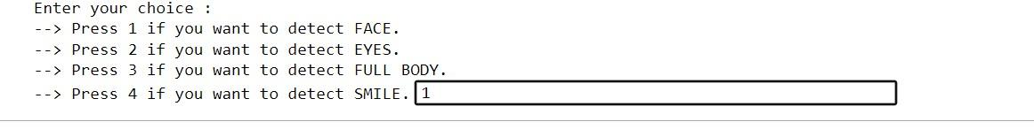

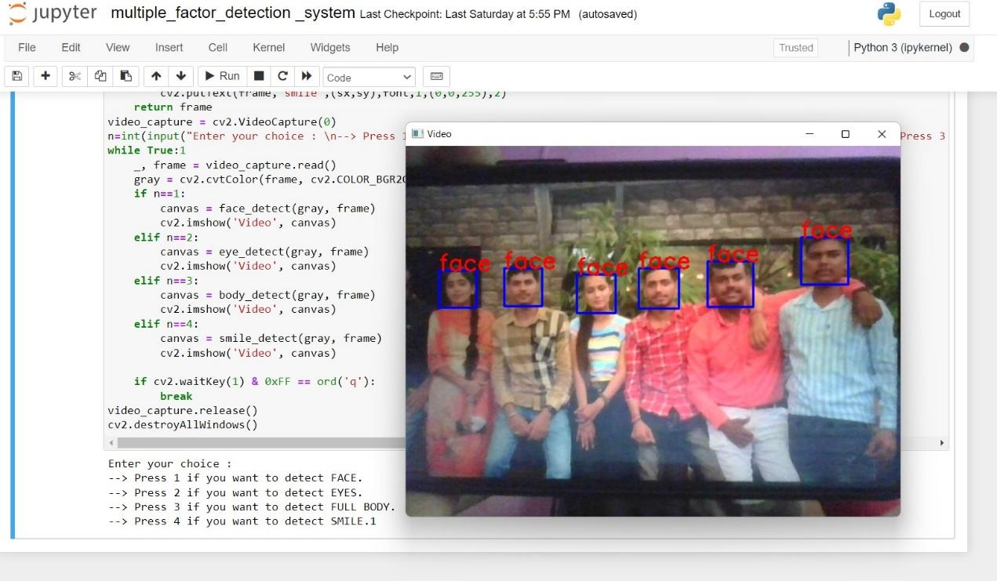

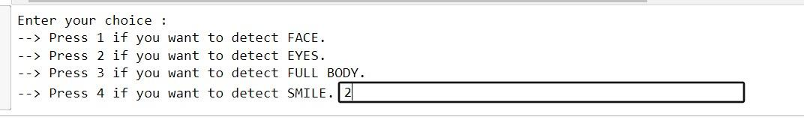

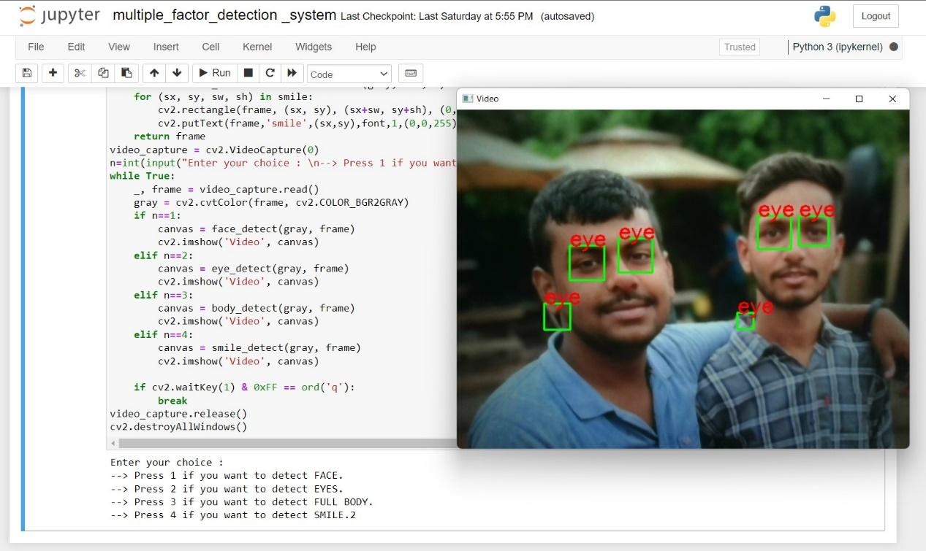

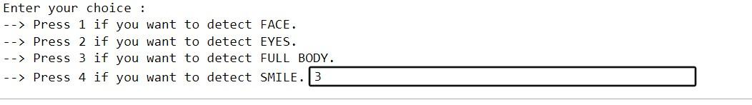

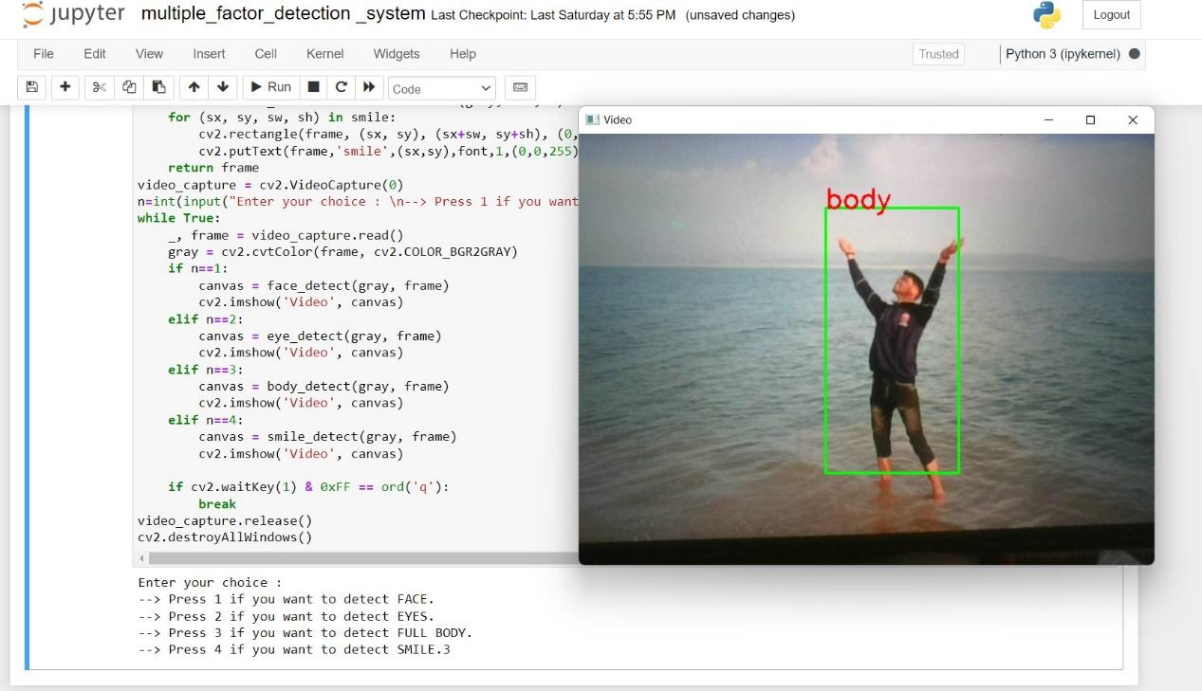

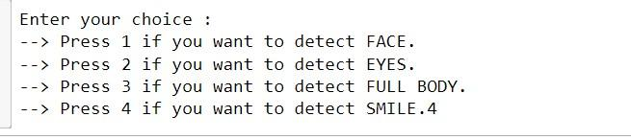

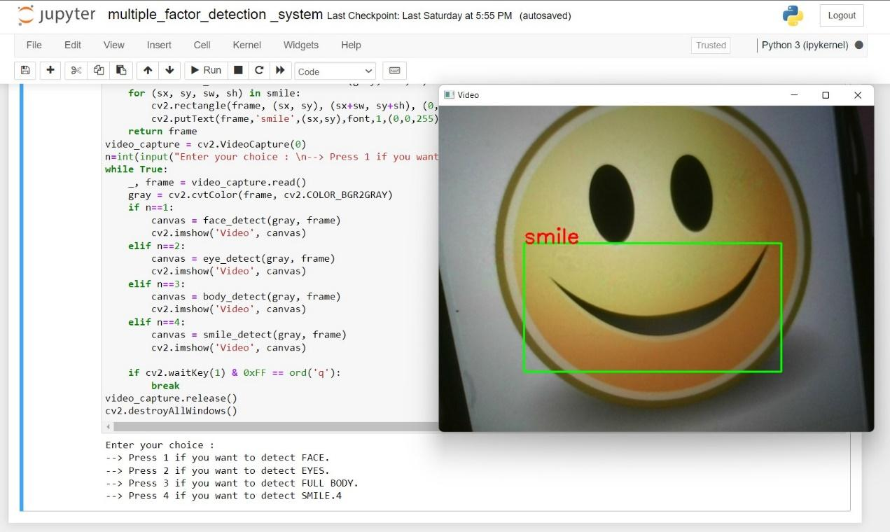

* BIBLIOGRAPHY

To complete this project successfully. We take help from the following website links & apps:

* [WWW.GOOGLE.COM](http://www.google.com)
* [WWW.YOUTUBE.COM](http://www.youtube.com)
* [WWW.WIKEPEDIA.COM](http://www.wikepedia.com)